Appendix A - Description of the subject of the contract for the delivery of precision positioning stages for the PolyX beamline at the SOLARIS National Synchrotron Radiation Centre

A 5-axis system for sample positioning
The 5-axis system will be used for sample positioning for µXRF, µXRF-CT, µCT and newly developed sub-micron multi-beam microscopy with polycapillary optics with sub-micrometer precision. The scheme of the system is presented in Fig.1. The order of the stages and their dimensions result from required travel ranges, space restrictions and possible collisions with optics and detectors. Height of the systems should be h_{min}=(335+/-10) mm in the lowest Z stage position.
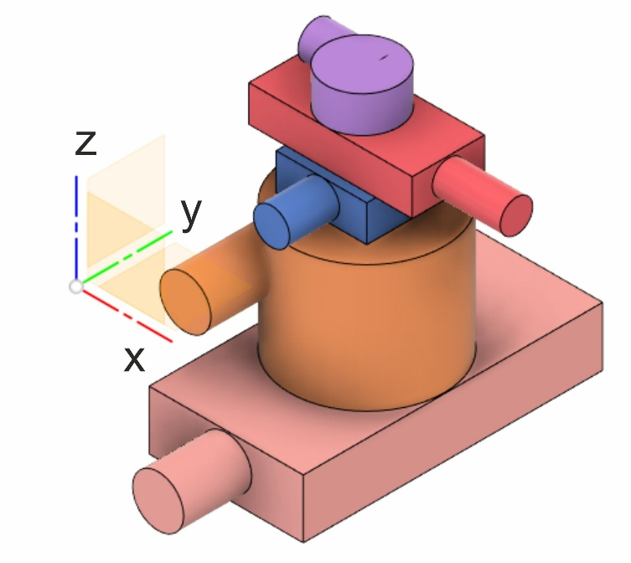
Figure 1. The 5-axis system for sample positioning

Purpose of the stages:

Stage Y: precisely moves the sample along the beam direction,
Stage Z: change the height between experimental modes and slow scanning (~1 mm/s speed),
Stage θX: alignment of the rotation axis perpendicular to the beam,
Stage X: sample centering and faster scanning (~10 mm/s)
Stage θZ: sample rotation.

Specifications of stages in the 5-axis system:

Y-stage:
Example | LINEAR STAGE HUBER 5101.35-150X2 with absolute encoder
Table size [W x L] | 170 mm x 170 mm
Travel range | +/- 75 mm
Width | 170 mm
Height [without motor] | < =70 mm
Length [without motor] | <=350 mm
Accuracy – open loop | +/-8 µm
Repeatability (unidir.) open loop | +/- 2 µm
Reversal error open loop | 4 µm
Material (base/slide) | Al
Max. load | 1500 N
Min. drive torque | 0.6 Nm
Stiffness | 0.7 ”/Nm
Weight [without motor] | < 10 kg
Motor: | e.g. VEXTA PKP266 D14BA2 (TS 78411) 120 Ncm, flange 56 mm, 200/400 steps/rev. Double Shaft. Connectors: see Appendix CS1
Encoder: | Renishaw Resolute, BISS-C, 32-bit, 5 nm  or equivalent, SUB-D9 connector,  cable up to 5 m.
Limit switches | Adjustable, mechanical, NC

Z-stage
Example | Z-STAGE HUBER 5103.A20-90X2 with absolute encoder, Pitch 0.06 mm  Custom tapped hole pattern for mounting of 1-Circle Segment 5202.60
Travel range | +/- 45 mm
Pitch | 0.06 mm
Table size | 170 mm x 170 mm
Width | <=170 mm
Height [at lowest position] | <= 140 mm
Length [without motor] | <=170 mm
Accuracy – open loop | +/-3 µm
Repeatability (unidir.) open loop | +/-1 µm
Reversal error open loop | 8 µm
Material (base/slide) | Al
Max. load | 1500 N
Min. drive torque | 0.3 Nm
Stiffness | 2.5 ”/Nm
Weight [without motor] | <= 11 kg
Motor: | e.g. VEXTA PKP266 D14BA2 (TS 78411)  120 Ncm, flange 56 mm, 200/400 steps/rev. Double Shaft.  Connectors: see Appendix CS1
Encoder: | Renishaw Resolute, BISS-C, 32-bit, 5 nm  or equivalent, SUB-D9 connector,  cable up to 5 m.
Limit switches | Adjustable, mechanical,NC

θX -Tilt
Example | CIRCLE SEGMENT HUBER 5202.60-X1  Custom tapped hole pattern for mounting 5101.10-100 AND 5101.20-100
Travel range | +/-14°
Table size | 100 mm x 100 mm
Height [without motor] | < 42 mm
Accuracy – open loop | +/- 25’’
Gear | 360:1
Height of rotation | 110 mm
Repeatability (unidir.) open loop | +/-3 ‘’
Reversal error open loop | 6 ‘’
Material (housing/worm gear) | Bronze
Max. load | 500 N
Min. drive torque | 0.45 Nm
Weight [without motor] | <= 4 kg
Motor: | e.g. VEXTA PKP244D15B2  48 Ncm, flange 42 mm, 200/400 steps/rev. Connectors: see Appendix CS1
Encoder: | None
Limit switches | Adjustable, mechanical.NC

X-stage:
Example | LINEAR STAGE 5101.10-100X2 with absolute encoder
Travel range | 100 mm
Table size | 80 mm x 81 mm
Width | <81 mm
Height [without motor] | < 35 mm
Length [without motor] | <220 mm
Accuracy – open loop | +/-15 µm
Repeatability (unidir.) open loop | +/-2 µm
Reversal error open loop | 4 µm
Material (base/slide) | Al
Max. load | 250 N
Min. drive torque | 0.1 Nm
Stiffness | 4 ”/Nm
Weight [without motor] | < 2 kg
Motor: | e.g. VEXTA PKP223D15B2  5 Ncm, flange 28 mm, 200/400 steps/rev.  Connectors: see Appendix CS1
Encoder: | Renishaw Resolute, BISS-C, 32-bit, 5 nm  or equivalent, SUB-D9 connector,  cable up to 5 m.
Limit switches | Adjustable, mechanical

θZ-rotation

Example | 1-CIRCLE GONIOMETER 408 X3 W2 with absolute encoder + adapter for mounting on 5101.10-100 stage
Travel range | 360°
Table size | <=80 mm dimater
Height [without motor] | < 50 mm
Accuracy – open loop | +/-25’’
Gear | 180:1
Repeatability (unidir.) open loop | +/-2 ‘’
Reversal error open loop | 10‘’
Eccentricity | 2 µm
Wobble | 8’’
Material (housing/worm gear) | Aluminium/Bronze
Max. load (hot/ver) | 400 N/125 N
Min. drive torque | 0.05 Nm
Weight [without motor] | <= 1.5 kg
Motor: | e.g. VEXTA PKP223D15B2  5 Ncm, flange 28 mm, 200/400 steps/rev. Connectors: see Appendix CS1
Encoder: | Renishaw with Resa-scale BISS-C, 32-bit, or eqivalent
Limit switches | mechanical.NC

A 2-axis system for detector positioning with respect to the SAMPLE
The 2-axis system will be used for positioning of two detectors: a hybrid pixel detector and a x-ray microscope with a camera. The load on the system will be from 30-50 kg and the torque MX will be 30-50 Nm. The 2-axis system is presented in Figure 2.
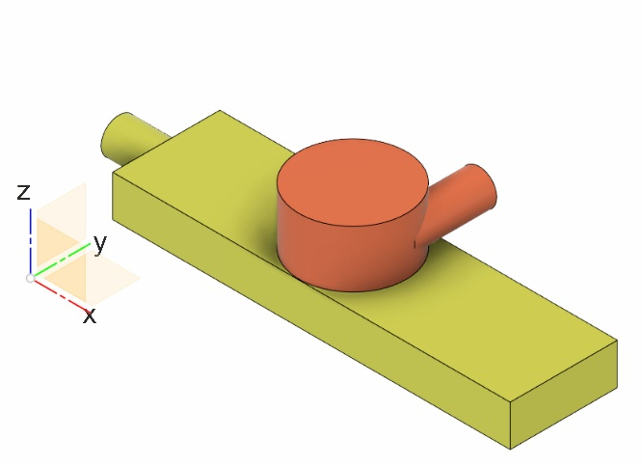
Figure 2 The 2-axis system for detector positioning

Specifications of stages in the 2-axis system:

X-Stage
Example | LINEAR STAGE HUBER 5101.35-300X1 with absolute encoder
Table size [W x L] | 170 mm x 170 mm
Travel range | +/- 150 mm
Width | 170 mm
Height [without motor] | < 70 mm
Length [without motor] | <350 mm
Accuracy – open loop | +/-20 µm
Repeatability (unidir.) open loop | +/-3 µm
Reversal error open loop | 6 µm
Material (base/slide) | Al
Max. load | 1500 N
Min. drive torque | 0.6 Nm
Stiffness | 0.7 ”/Nm
Weight [without motor] | < 15 kg
Motor: | e.g. VEXTA PKP266 D14BA2 (TS 78411) 120 Ncm, flange 56 mm, 200/400 steps/rev. Double Shaft.  Connectors: see Appendix CS1
Encoder: | Renishaw Resolute, BISS-C, 32-bit, 5 nm  or equivalent, SUB-D9 connector,  cable up to 5 m.
Limit switches | Adjustable, mechanical, NC

Z-stage
Example | Z-STAGE HUBER 5103.A20-40X1 with absolute encoder, Pitch 0.02 mm
Travel range | +/- 20 mm
Pitch | 0.02 mm
Table size | 170 mm x 170 mm
Width | <=170 mm
Height [at lowest position] | <= 90 mm
Length [without motor] | <=170 mm
Accuracy – open loop | +/-5 µm
Repeatability (unidir.) open loop | +/-3 µm
Reversal error open loop | 12 µm
Material (base/slide) | Al
Max. load | 1500 N
Min. drive torque | 0.3 Nm
Stiffness | 1.5 ”/Nm
Weight [without motor] | <= 7.5 kg
Motor: | e.g. VEXTA PKP266 D14BA2 (TS 78411)  120 Ncm, flange 56 mm, 200/400 steps/rev. Double Shaft.  Connectors: see Appendix CS1
Encoder: | Renishaw Resolute, BISS-C, 32-bit, 5 nm  or equivalent, SUB-D9 connector,  cable up to 5 m.
Limit switches | Adjustable, mechanical,NC

Motors and connectors
- Solaris standards are described in Appendix CS1 (similar to ESRF/MAXLAB). After agreement different solutions can be also considered
- All motors should be 2-phase (bipolar) stepper motor suited for micro-stepping (eg. Vexta PK….).
- Motor connectors should be military as described in CS1, for smaller stages SUB-D15 connectors are acceptable.

Design
After signing the contract, the supplier should provide a 3D step model of both systems, their wiring schemes, and most important motorization parameters from table in Section 10.3 of Appendix CS1. Manufacturing is possible only after approval of the design by SOLARIS.

Test and MounTing
All stages should be tested at factory. Motors and encoders should be mounted.

