Appendix A - Description of the subject of the contract for the Superconducting Wiggler for the SOLCRYS beamline at the SOLARIS National Synchrotron Radiation Centre, Ref. No: 80.272.104.2020
Modification – 26.05.2020
Table of Contents
1. Introduction 2
2. Scope of supply (deliverables) 3
3. Time scales 4
4. Mechanical requirements and site constrains 4
5. Requirements for the Subsystems of SCW 6
5.1. Magnet 6
6.1.1. Limits for the magnetic field quality at each current from > 0 A to maximum: 7
5.1.2. Prototype 8
5.1.3. Magnet Quenching 8
5.2. Cryostat and cryogenic system 9
5.3. Vacuum system 9
5.4. Power supply, current leads and quench protection system 11
5.5. Control and interlock system 11
5.5.1. Cryostat control and monitoring 11
5.5.2. Interlocking 12
5.5.3. User interface 12
6. Contract conditions 12
6.1. Documents to be provided/agreed with the final design review 12
6.2. Delivery and acceptance-test 13
6.2.1. Documentation to be provided 13
6.2.2. Factory acceptance test 13
6.2.3. Site acceptance test (minuted) 14
7. Installation, Commissioning, Training 14

1. Introduction

National Synchrotron Radiation Centre SOLARIS

SOLARIS is a 1.5 GeV storage ring based on the double-bend achromat (DBA) magnetic lattice (12 DBA cells). Electron bunches are injected from the linac (linear accelerator) at the energy ~550 keV, then they are ramped to the final energy of 1.5 GeV in the storage ring. Maximum number of the bunches is 32, and maximum current of the stored beam is 500 mA. The design horizontal beam emittance is 6 nmrad, vertical is 60 pmrad. The critical energy of the synchrotron radiation beam from the bending magnet (magnetic field of 1.31 T) is approximately 1.98 keV
The subject of the order is purchasing and installation of an insertion device – a superconducting multipole wiggler operating at the magnetic field of 4 T (SCW) in SOLARIS storage ring for the needs of the SOLCRYS beamline. SCW should shift the critical energy of the photon beam to the value of approximately 6 keV, and increase the flux, therefore making high fluxes of high-energy photons achievable.
The main application of this insertion device will be the generation of synchrotron radiation in the hard X-ray range for the SOLCRYS beamline. SOLCRYS is planned as a beamline consisting of two independent optical branches, terminated by two endstations. The routine operation mode of both endstations will be simultaneous and independent. The detailed technical parameters of the beamline are presented below. However, it should be here emphasized that one of the key requirements for the insertion device, which is the subject of the order and whose parameters are defined in detail later, is the long-term stability of the horizontal and vertical radiation source position.
The design of SOLCRYS beamline includes the separation of both optical branches by means of a fixed mask located close to the source. Any source position instability (source drift) may impede or even block the required parallel and independent operation of both endstations.
The first endstation (denoted as “PX” – protein crystallography) is dedicated to X-ray diffraction studies (especially to protein crystallography) and will use the central part of the radiation cone generated by the superconducting wiggler. It will be necessary to focus the synchrotron radiation beam for this PX branch to the spot dimensions below 50 µm at the same time ensuring the maximum flux of X-ray photons. Ultimately, during routine measurements, the synchrotron radiation beam, previously focused on optical elements, will be cut to the size of 10 µm (horizontally and vertically) using a collimating slits system. Therefore, proper stability of the radiation source position is crucial. The Contractor should therefore propose appropriate technological solutions that ensure the stability of the source during long-term serial measurements.
The second facility is designed as a small angle X-ray endstation (denoted as “SAXS”). This branch will use side a part of the SR beam from SCW. The SR beam after focusing on all optical elements should be characterized by low divergence and high flux.

Desired parameters of the beam at the sample position at the PX endstation are:
- spot size with vertical dimension of the order of 50 µm (dimension of focused beam),
- energy resolution δE/E = 1.4·10⁻⁴ when operating with double crystal monochromator,(DCM) and
δE/E ≈ 0.5 % when working with a double multilayer monochromator (DMM),
- flux on the order of ~ 10¹³ ph/s (DCM) and ~10¹⁴ ph/s (DMM).at 12 keV photon energy

Desired parameters of the beam at the sample position in SAXS endstation are:
- spot size with vertical dimension on the order of 50 µm,
- energy resolution δE/E = 1.4·10⁻⁴ when working with a double crystal monochromator,
and δE/E ≈ 0.5 % operating with a double multilayer monochromator,
- flux of the order of ~ 10¹² ph/s (DCM) and ~10¹⁴ ph/s (DMM). at 12 keV photon energy.
Superconducting wiggler should be designed in a way to fulfill those requirements.

The photon energy range used by the SOLCRYS beamline is 4 – 25 keV. Total power emitted from the insertion device should not exceed the value of ~14 kW.

2. Scope of supply (deliverables)

The scope of contract covers design, manufacturing, factory acceptance tests (FAT), supply, installation, site acceptance tests (SAT) and commissioning of a superconducting wiggler (SCW) with indirect cooling in the SOLARIS storage ring. The SCW should include all necessary components such as complete superconducting magnet structure, power supplies for the magnet, electron beam vacuum chamber, design and requirements for the complete straight section components (bellows, tapers between a standard bending magnet vacuum chamber of the SOLARIS storage ring and the insertion device vacuum chamber, valves, absorbers) and cryostat with a vacuum system, mechanical support system, current leads, quench protection system, control, monitoring and interlock system with all necessary instrumentation and software, in order to ensure proper and reliable operation of the SCW systems. The SCW cryosystem works in a closed-loop cycle, thus refilling of liquid helium is not necessary. In order to ensure successful and reliable operation of the SCW the cryostat has to be equipped with the cryocoolers recirculating liquid helium. Due to the fact that the cryocoolers are manufactured by a separate group of producers, they will be purchased by the Awarding Authority in accordance with the full technical specification resulting from the design of the wiggler cryogenic system containing detailed description of parameters and functionality, the catalogue numbers and models. The data should be provided by the Contractor in accordance with requirements of the Agreement (the contract template).

3. Time scales

In the offer, the Contractor should clearly specify proposed time schedule for reaching and delivering the milestones:
- Design of the wiggler magnet with all necessary calculation of the magnetic field and emitted beam properties
- Fabrication of magnet prototype
- Design of the cryostat
- Preliminary Design Review (PDR)
- Design review meeting at SOLARIS
- Final Design Review (FDR)
- Fabrication of full magnet
- Tests of the magnet in the bath cryostat
- Fabrication of the Contractor cryostat
- Factory acceptance test (FAT) of the magnet in Contractor cryostat
- Transportation of all systems to the SOLARIS site
- Site Acceptance Tests (SAT)
- Installation of the system in the SOLARIS storage ring and the Final Acceptance Tests
- Training of the SOLARIS staff

4. Mechanical requirements and site constrains

The SCW will be installed in the straight section 02 of the SOLARIS storage ring. The nominal height of the photon beam axis is 1300 mm above the floor level. The photon beam from the bending magnet is horizontal and parallel to the floor. Maximum height available in the storage ring tunnel is 2600 mm. The general Solaris standards and practices are described in the Appendix MECH1-Mechanics.pdf and should be followed during the design and installation phases.
Maximum length available in the section-2 is 3335 mm. Additional space for standard components to has be included:
RF valves: 2 x 75 mm = 150 mm
Bellows, tapers, heat absorber
: min. 2 x 230 mm = 460 mm need to be designed (or designed and produced as an option) by the Contractor.

For alignment, number of threaded holes made according to Solaris standard (described in appendix ALIGN - Guidelines in field of alignment.pdf) has to be prepared, as a supports for Leica RRR (1.5 inch diameter) reflectors. The required number and location of the fiducial points has to be agreed with Solaris. After the agreement, Solaris will send the sockets to the Contractor for mounting and fidualisation. The fiducial points have to be referenced to the magnetic plane and the axis within 0.03 mm and to the angular accuracy of less than 0.3 mrad. The requirements for the alignment are defined in attachment Appendix ALIGN - Guidelines in field of alignment.pdf. The center of the flanges and the magnetic axis must coincide within 0.2 mm. The cryostat should be supported by special girder allowing the possibility to correct position in all directions. The support system has to allow for alignment of the SCW to the accuracy of 0.03 mm within a range of at least ± 15 mm vertically and ± 30 mm horizontally and longitudinally. SOLARIS will provide common assembly tool as agreed with the Contractor. The SCW must be equipped with transportation loops to fit the SCW with the crane to its position in the ring. The crane (8T) provides 4 m as the maximum height of crane hook above ground.
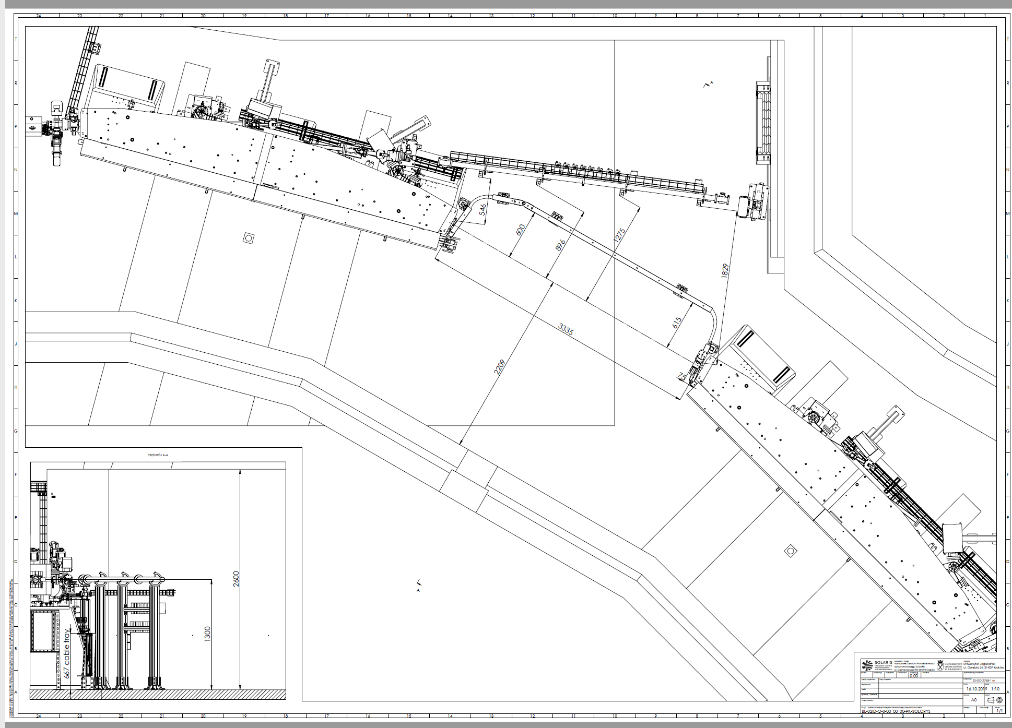
Fig. 1. Dimensions of the straight section (02) between DBA01 and DBA02 from VK2 flange to VK1 flange, and from RF valve to RF valve.
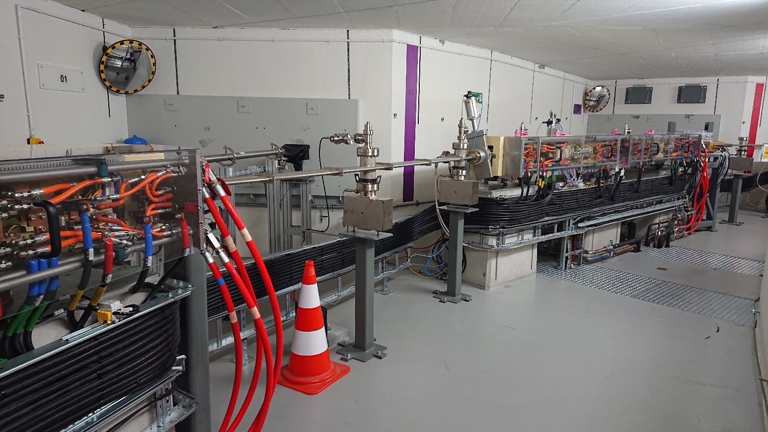
Fig. 2. Photograph of the straight section 02 in the Solaris storage ring tunnel.

Additional space for tapers and absorbers (to be designed in agreement with SOLARIS) has to be included. Overall length of the SCW infrastructure from flange to flange should not exceed 2.5 m.

5. Requirements for the Subsystems of SCW

5.1. Magnet

Design of the magnetic system must ensure the compensation of the 1st and 2nd field integral. General properties of the magnetic structure of SCW to be constructed are listed in Table 1.

Table 1 Properties of the magnetic structure of SCW.
Period length | 50±2 | mm
Magnetic field | 4 | T
Maximum field-on axis | 4.2 | T
Number of pole pairs | Up to 70
Deflection parameter K | Up to 19
Full (inner) vertical aperture of the vacuum chamber | >8 | mm
Full (inner) horizontal aperture (entry/exit) of the vacuum chamber | >60 | mm
Magnetic length | Up to 1.8 | m
Length flange-to-flange | Up to 2.5 | m
Pole scheme | -1/4, 3/4, -1, 1...-3/4, 1/4
Transverse field homogeneity at  all field levels at x=±20 mm, z=0 | ΔBz/Bz ≤ 0.20 %
Maximum stray field on axis at each end of cryostat | 10⁻³ | T
Maximum ramping time | < 5 | Min
Liquid helium consumption (at normal operation) | 0 | l/h
Period for LHe refill with beam | > 6 | Months
LHe boil-off during quench | < 15 | L
Radiated power at 100 mA of electron beam current | ~ 2.8 | kW
Field stability (2 weeks) at 0.5-4 T | < 10⁻⁴

6.1.1. Limits for the magnetic field quality at each current from > 0 A to maximum:
Table 2. Limits for the magnetic field quality.
1 field integral horizontal | <10⁻⁴ | Tm
2 field integral horizontal | <10⁻⁴ | Tm²
1 field integral vertical | <5·10⁻⁵ | Tm
2 field integral vertical | <5·10⁻⁵ | Tm²
Quadrupole component | < 0.1 | T
Sextupole component | < 0.5 | T/m
Roll off at ±10 mm | < 0.5 | %
Maximum field variation | ±1 | %

Vertical steering magnets must be installed if necessary to compensate possible vertical offsets of the electron beam. The power supplies for steering magnets have to be agreed with SOLARIS. The agreed power supplies will be provided by the Contractor. The design should accommodate the space for the steering magnets taking into account available space in the straight section and the auxiliary vacuum components that need to be installed as (RF valves; tapers, bellows, heat absorbers, additional BPMs if required).
The Contractor is free to employ suitable correction strategies e.g. additional corrector magnets/trim coils, shimming etc. to achieve the field integrals and integrated multipole field components as specified in Table 2. The correction strategy should be reported in the design report.
The SCW will be ramped from the minimum magnetic field corresponding to the minimum stable current to its maximum magnetic field after the energy of the stored electron beam at 0.54 GeV is increased to 1.5 GeV. Therefore 1st and 2nd field integrals and integrated multipoles should stay within the limits as specified in Table 2 during ramping of SCW from the minimum current to its maximum value. If the correctors/trim coils are used, a look up table of corrector currents and main coil currents should be provided by the Contractor.
The magnet core should preferably be constructed of low carbon steel (ARMCO). The composition details with certificate, B-H curve, and inclusion testing report should be supplied by the Contractor.
The superconducting wires should be made of high quality Nb-Ti material. Test reports and specification of the selected superconducting wires should be provided. The selection of wire diameter the ratio of the used wire materials should meet the requirements of operational performance and quench protection. The superconducting wire should be purchased from the
reputable manufacturer who has supplied superconducting wires for the working magnets in storage rings.

5.1.2. Prototype
Short prototype of the superconducting magnet (coils) with 6 full and 2 (1⁄4, 3⁄4) poles has to be constructed and tested prior to construction of the final SCW. The prototype has to meet the specification of the final magnet. Construction and assembly of the prototype and final magnet should be identical.

5.1.3. Magnet Quenching

The magnet protection system must withstand quenches safely without damage. The liquid He boil- off at a single quench must be smaller than 15 liters and blow-off must be avoided. The quench protection must be based on diodes and/or resistors parallel to the coils and comparison of the voltage of the corresponding coils.

5.2. Cryostat and cryogenic system

The cryogenic system must be based on a cryocooler allowing zero boil-off operation with e-beam. The cryostat should be cooled by a closed loop helium circulation system and/or thermomechanical coolers of proven reliability. The Contractor has to specify the cryocoolers in detail (see the point 2).
The period between He refills must be longer than 6 months for operation with e-beam. Moreover the intervals for maintenance must be longer than 1 year. To guarantee maintenance of the SCW within standard SOLARIS shutdown time, the cooling time of the SCW must be shorter than 5 days and the warming up time must be shorter than 3 days by standard warm up. Therefore, the magnet shall be equipped with a heater. Liquid He consumption during normal operation should be zero. The Contractor should provide a detailed description of maintenance, cooling down and warming up procedures. Maintenance procedures that require a warm up of the SCW must be avoided and, if necessary, clearly indicated.
There must be no cold points which will cause atmospheric moisture to freeze or condense on the surface of the cryostat or any equipment to be supplied . The cryostat must withstand a possible beam heat load to the flat vacuum chamber. Beam heat load produced by the presence of the taper (RF effects) should be intercepted at room temperature or at the 60 K or 20 K shield level. The cold mass of the SCW has to be protected against synchrotron radiation.
All main components of the cryogenic system (magnet, current-leads, cold-head-stages, shields, taper etc.) must be equipped with appropriate calibrated temperature sensors and connected to the control-system.
Liquid helium transfer line for filling of the cryostat will be provided by the Contractor. The connecting place with the standard Dewar vessel will be agreed with SOLARIS.
The cryogenic system working with the cryocoolers should be of the design that demonstrated successful operation in similar/comparable applications. To prevent vibration of LHe tank with the magnet exciting by coolers working in pulse mode all connections between the external housing and LHe tank should be designed and fabricated with use of elements extinguishing the vibrations. The disturbance due to coolers work to the beam orbit must be less than 1 µm.

5.3. Vacuum system

The isolation vacuum must be sustained and permanently monitored via the SCW control system. The isolation vacuum must be equipped with suit ports for pumps and gauges. The specification of connection ports should be agreed with SOLARIS. All components for pumping and monitoring of isolation vacuum have to be agreed with SOLARIS. Pressure gauges, pumps and valve(s) will be provided by the Contractor.
The transition of the cold to the warm chamber must be smooth. The entrance and exit flanges must be of CF type and their dimension should be agreed with SOLARIS. Overall length of the SCW from exit to entrance flange should not exceed 2500 mm. Tapers, bellows, absorbers have to be considered in agreement with SOLARIS. The transitions must be designed to accommodate the thermal load from the e-beam.

The vacuum insulation space must be fitted with a burst disc. The helium circuits must be fitted with a pressure relive valve (PRV) on independent ports which cannot be blocked by unexpected air ingress. The cryostat must be designed and manufactured in accordance with the pressure equipment directive (PED) and be CE marked accordingly.
The two vacuum chambers (e-beam-chamber, isolation vacuum) must be stable against atmospheric pressure and independently ventable. Material for construction of the outer vessel and helium cryostat should be non-magnetic austenitic stainless steel of suitable grade with magnetic permeability of ≤ 1.02. All vacuum and pressure vessels have to be designed according to the SOLARIS vacuum standards. The SOLARIS vacuum standards are described in Appendix VAC1 – (Guidelines for UHV-components at Solaris.pdf) and VAC2 (Technologies and materials for SOLARIS UHV devices.pdf).
Electron beam (“e-beam”) vacuum chamber is a part of liquid helium vessel and should be kept at 4.2 K temperature. To protect the e-beam vacuum chamber from the heating by the electron beam, inner surface of the chamber should be covered with the liner made of oxygen-free copper, connected from both ends with the cold heads of cryocoolers to keep temperature constant. The second purpose of the liner is to isolate the vacuum chamber from the room temperature of the walls of the wiggler cryostat and storage ring parts. There is RF transition (valves, bellows, tapers through standard CF flange) between the liner and the storage ring vacuum chamber. The vacuum chamber needs to be designed to reduce the induced heating by the stored electron beam of 500 mA at energy of 1.5 GeV. The design of the vacuum chamber should also take into account the reduction of the heat due to higher frequencies generated by the bunched structure of the beam. The harmonic number of SOLARIS storage ring is 32. The bunch charge is 5nC/bunch. The bunch length is 15-60 mm, its revolution frequency 3.125 MHz. The vacuum chamber needs to be designed also to reduce the incident heat load from synchrotron radiation of MPW itself and upstream bending magnet edge radiation.

5.4. Power supply, current leads and quench protection system

All power supplies of the SCW have to be specified in detail by the Contractor and to be agreed with SOLARIS. The agreed power supplies will be procured and provided by the Contractor. The power supply should provide stability which ensures a long term stability (<10 ppm) of the magnetic field specified in section 6.1.
The Contractor should provide all necessary current leads required for the SCW magnet system. Suitable current leads, e.g. a combination of normal conducting and high temperature superconductor (HTS) current leads to minimize the heat load may be chosen.
The Contractor should provide suitable quench protection system for the SCW. The system may consist of quench detection system, electromechanical switch, dump resistor or cold diode (or a combination of both). Estimation of maximum possible voltage and temperature rise during quench should be made. The quench protection system should be able to prevent damage to the SCW system.

5.5. Control and interlock system

Control system of the SCW should include the following functions to ensure safe and reliable machine operation:
- Cryostat control and monitoring
- Power supplies control (current control) and monitoring
- Interlock protection
The control system should include the interface to the IOC, the design of the functionality in the IOC system and the development of the user interface. Interface communication (TANGO) has to be agreed with SOLARIS. The general requiremnts of the control system are described in the attachment Appendix CS0-SOLARIS Control System Standard.pdf.
The choice of IOC hardware and software development environment will be defined in agreement with SOLARIS and according to Solaris requirements and standards. The list of instrumentation required for SCW monitoring is presented below.

5.5.1. Cryostat control and monitoring

The minimum set of components required to monitor and control the cryostat includes: temperature sensors, LHe level meter in the magnet vessel, GHe pressure meter in the cryostat, flow meter, vacuum gauge to monitor the insulating vacuum. Monitoring of temperature should be provided at the critical locations in the cryostat, i.e. at the magnet, LHe vessel, radiation shields, current leads, etc. Total number of temperature sensors should be defined in the cryostat design.

5.5.2. Interlocking

Interlock signals are defined from the magnet and cryostat design. To ensure correct and safe operation of the device the interlock logic should be realized in hardware (not software). The documentation with details of the interlock levels description and interlock logic is to be provided by the Contractor. The following events should be considered as interlock signals in SCW control system:
- quench
- HTSC current leads overheat
Moreover the temperature sensor for LHe level warning signal should be used.
- pressure rise in the insulating vacuum and e-beam chamber
- cryocoolers fault
- etc.

5.5.3. User interface

The user interface may be structured with a main screen that summarizes the control and monitoring parameters of the SCW and additional engineering screens that provide full control and detailed monitoring information for each component of the system.

6. Contract conditions

6.1. Documents to be provided/agreed with the final design review

- Detailed design drawings, CAD model (step, dwg or dxf format) of the system including magnet, cryostat and support.
- Cryogenic and electric circuit diagrams.
- Final list of monitoring and interlock signals.
- Final list of recommended spare parts and cost.
- Detailed schedule.
- Type of wire, yoke, liner.
- Pole scheme.
- Final list of control parameter.
- Clarification of interface problems (e.g. pressure, water, crane, pumps, cabling, etc.).
- Items to be provided by SOLARIS (electricity, L-He, water, compressed air, etc.).
- Description of the control system.
- Test procedure for factory and site acceptance test.
- Detailed description of maintenance work, warming up and cooling down the SCW.

6.2. Delivery and acceptance-test

6.2.1. Documentation to be provided

All labelling and documentation must be in English. Documentation has to be supplied in electronic form (dwg, dxf, step, doc, xls, etc.). The main assembling units of SCW schemes have to be supplied in paper form (one set).

Documentation to be provided (exemption to be agreed):
- Complete drawing set (both 2D and 3D).
- Magnetic calculations.
- Thermal calculation.
- Maintenance documentation, including warming up and cooling down procedures.
- Documentation of control and interlock soft- and hardware.
- Documentation (manuals) of third party deliveries.
- Certificates of used materials (steel, cables, ect.).
- Magnetic measurements results.
- Factory acceptance test results.
- Final acceptance test results.

6.2.2. Factory acceptance test

- Field-measurement in 0.5 mm steps at 0, ±10, ±20 mm horizontal position.
- Field integrals measurements in 1 mm steps.
- Cooling and warming up.
- Quench test.
- He-consumption.
- Vacuum test, leak test, residual gas analyzer spectra. Mechanical measurements/test (alignment, gap, dimensions).
- Test of main and corrector power supplies.
- Field-Stability.
- Check of monitor and interlock signals.

6.2.3. Site acceptance test (minuted)

Without beam:
- Test of all components (power supplies, cryo-coolers etc.)
- Field integrals measurements in 1 mm steps.
- Cooling and warming up.
- Quench-test.
- He-consumption.
- Vacuum test: Pressure, leak test, residual gas analyzer spectra.
- Mechanical test (alignment, gap, dimensions).
- Local SCW control and interlock.
- Monitor-signals.

With beam:
- Quench-test.
- He-consumption.
- Orbit-distortion: At 1.5 GeV the h/v orbit distortion should be less than 50/1 μm rms.

7. Installation, Commissioning, Training
Installation and commissioning of SCW without beam in SOLARIS storage ring is the responsibility of the Contractor. Before installation commences, the Contractor should supply a full scheme of installation and the requirements. In case some special tools/jigs or specially qualified manpower is required for the assembly and installation, then they are to be arranged by the Contractor. After installation, the proper working of the SCW should be demonstrated by the Contractor. The final acceptance of the equipment is defined as the successful completion of the installation and commissioning of SCW without beam in SOLARIS storage ring and completion of the following final acceptance tests:
- Excitation of the SCW magnet system to the current level corresponding to the maximum on axis peak magnetic field of 4 T and demonstration of magnetic field ramp up and down.
- Demonstration of proper working of control and interlock system along with instrumentation, power supplies and vacuum system.
- Any other acceptance tests defined in this document deemed necessary by the purchaser to confirm the correct operation of MPW.
The Contractor should provide training for operation of the purchased system to at least three persons at the purchaser’s site. The condition of the final acceptance is that the Contractor must have provided full documentation as indicated throughout this specification to cover all systems embodied within this contract.

List of appendices:
  - MECH1-Mechanics.pdf
  - ALIGN - Guidelines in field of alignment.pdf
  - VAC1 – Guidelines for UHV-components at Solaris.pdf
  - VAC2 -Technologies and materials for SOLARIS UHV devices.pdf
  - CS0-SOLARIS Control System Standard.pdf

